**DAILY TASKS DAY 04**

1. **Create a user with name techie and give sudo access to the user:**

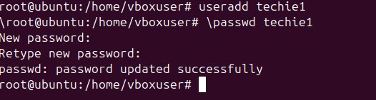



1. **Navigate to the home directory:**

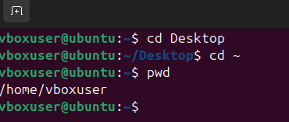

1. **Create a new directory:**
2. **List the contents of the directory:**
3. **Change the current directory:**

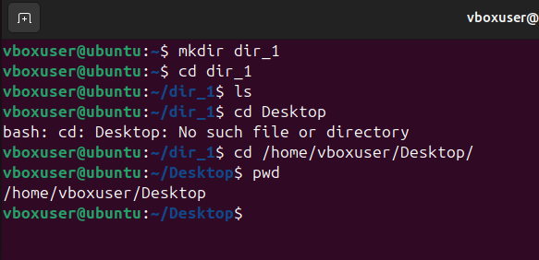

1. **Create a new empty file: touch filename**
2. **View the contents of the file: ls**

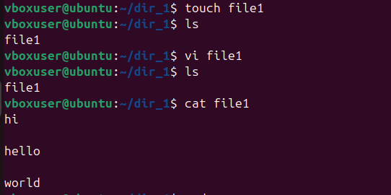

1. **Copy a file to another location: cp -r**

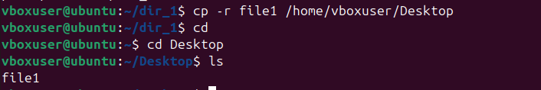

1. **Move a file to another location: mv filename /path/**

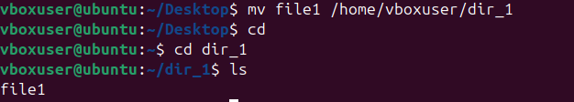

1. **Rename a file: mv oldfilename newfilename**
2. **Delete a file: rm**

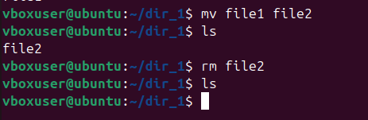

1. **Grant/revoke permissions on a file or directory:**

**chmod 761 filename**

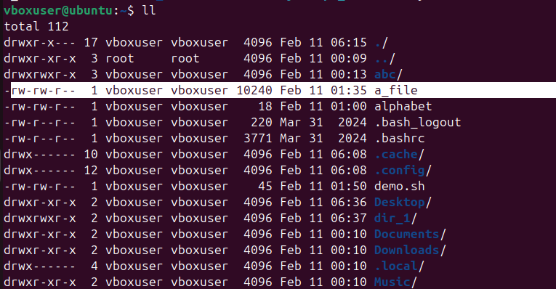

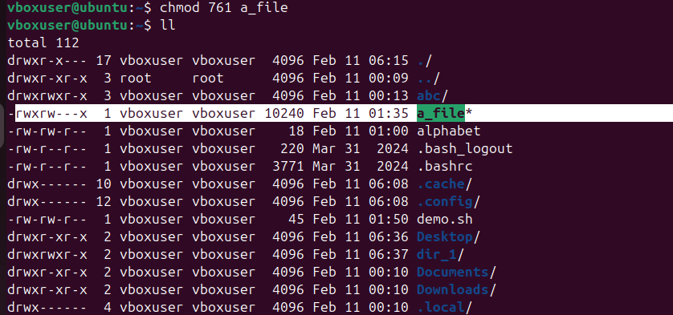

1. **View the current date and time: date**

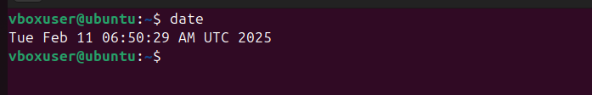

1. **Check the system uptime: uptime**

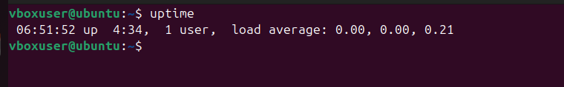

1. **View the running processes: ps -ef or ps aux (gives extra info. About CPU & memory)**

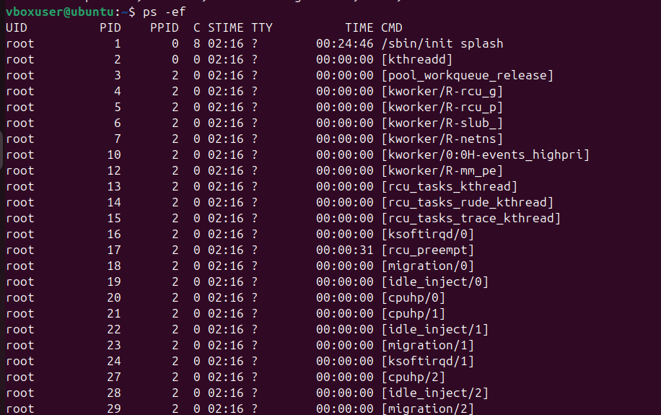

1. **Kill a running process:**

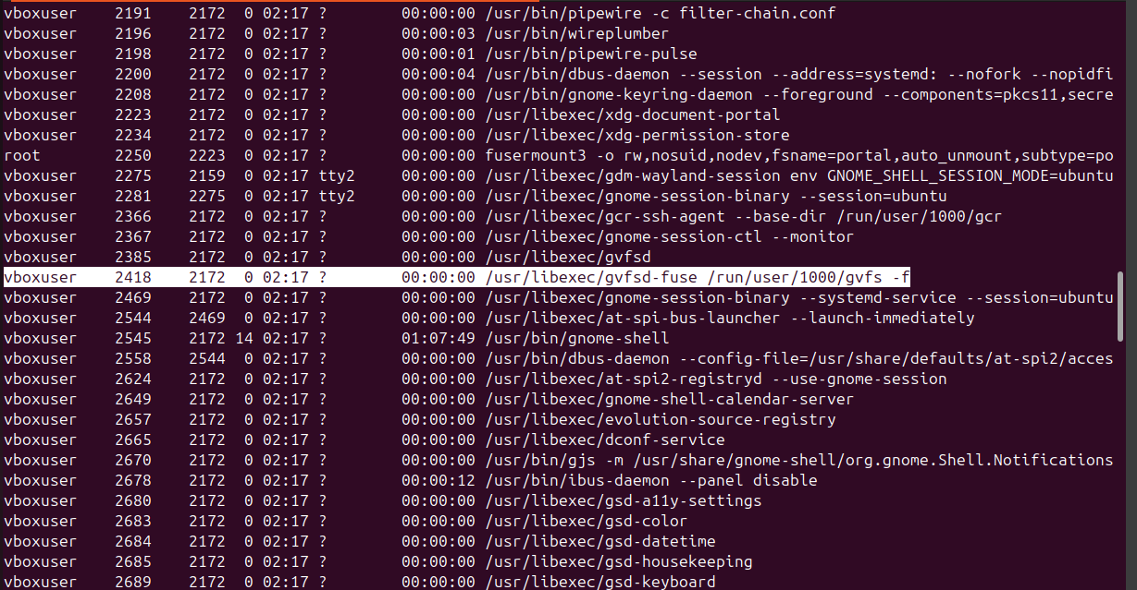

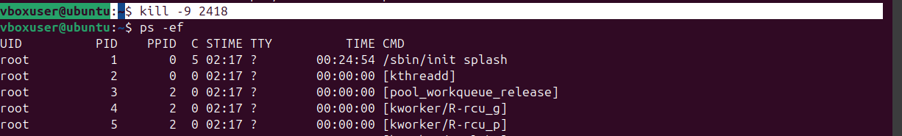

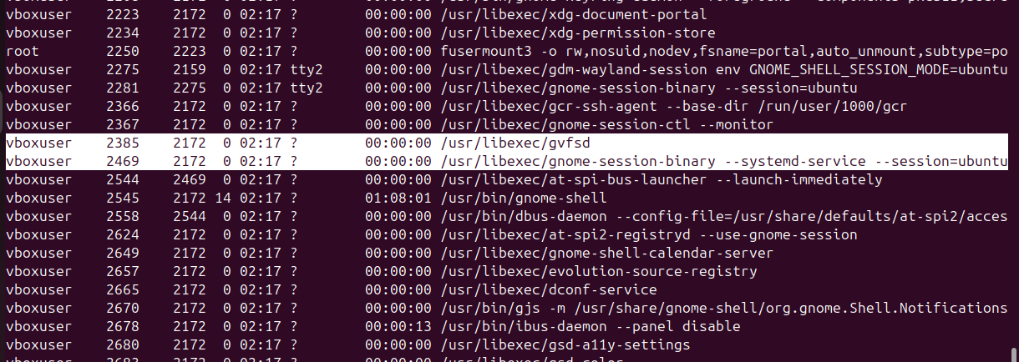

1. **Install a package using package manager:**

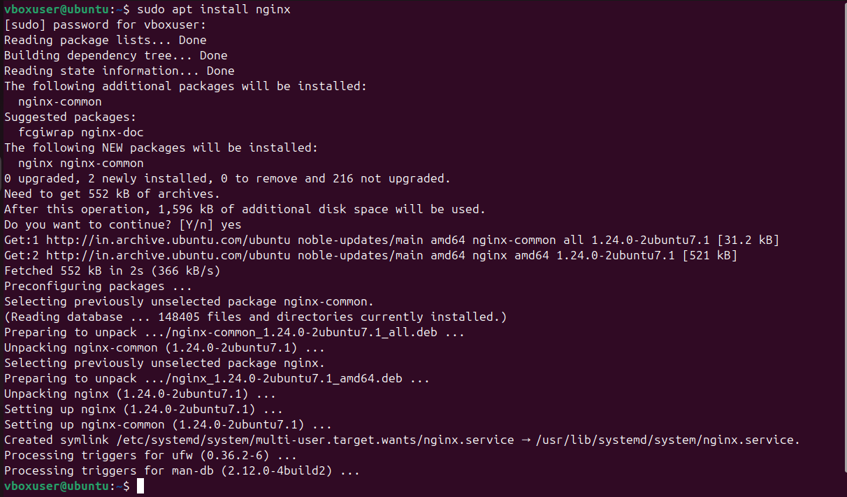

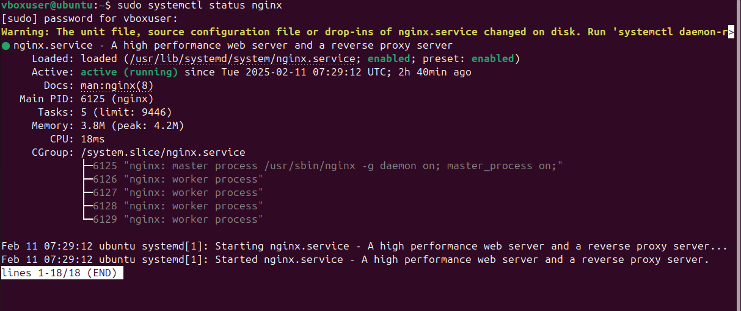

1. **Update the system packages:**

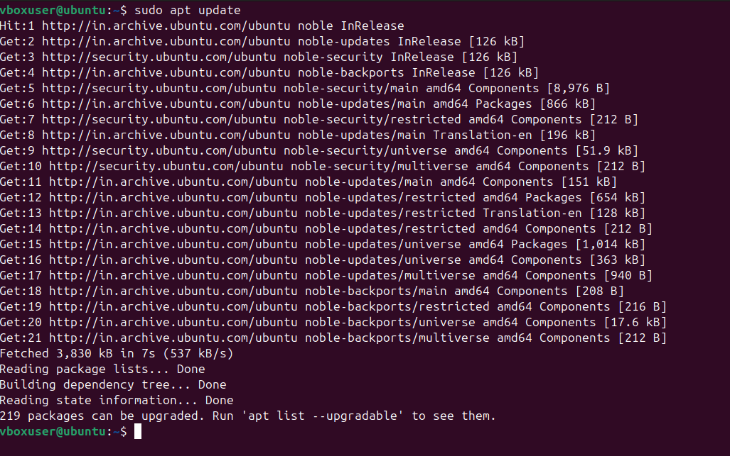

1. **Create a symbolic link:** A symbolic link is a shortcut that points to another file or directory.

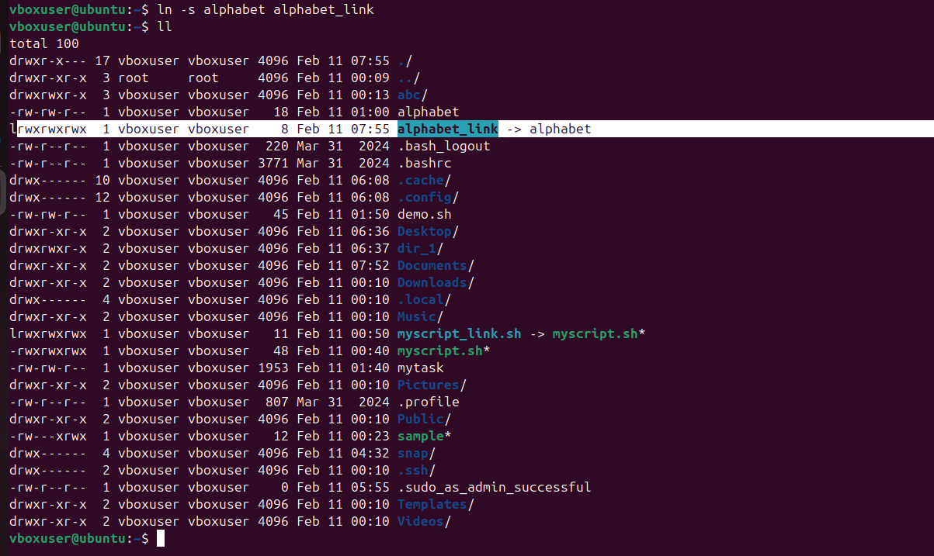

1. **Search for files using find command:**



1. **Compress and decompress files using tar:**

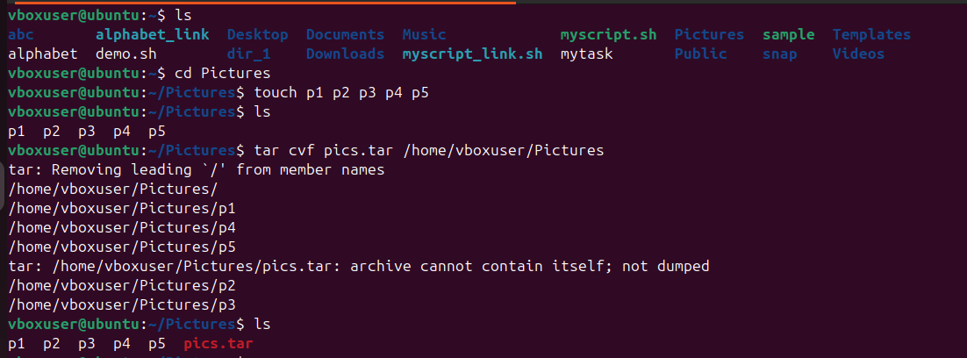

1. **Monitor system resources with top or htop:**

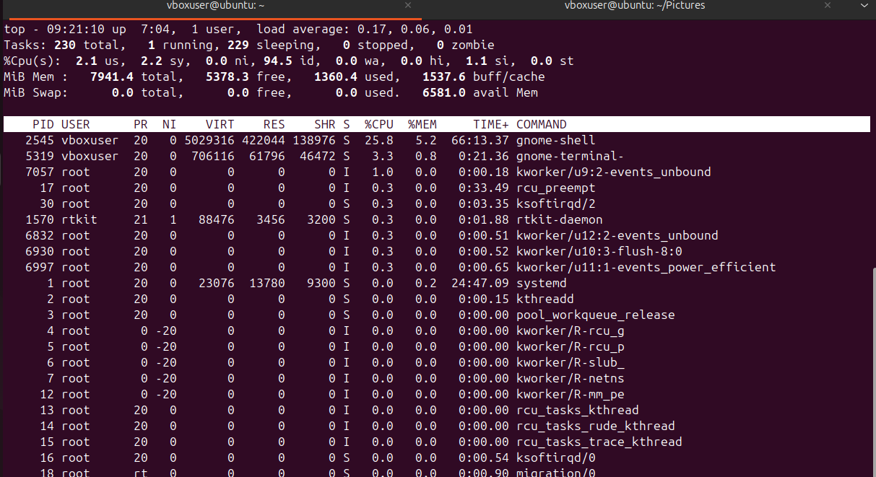

1. **Create and manage user groups:**

**To add -> groupadd**



**To check -> cat /etc/group**



* **To change the group name**



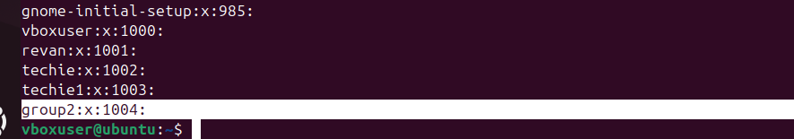

* **To delete the group**

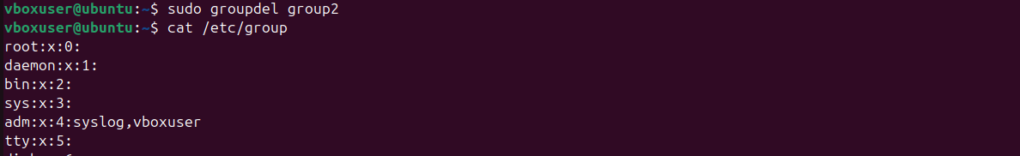

1. **Setup SSH password less authentication:**

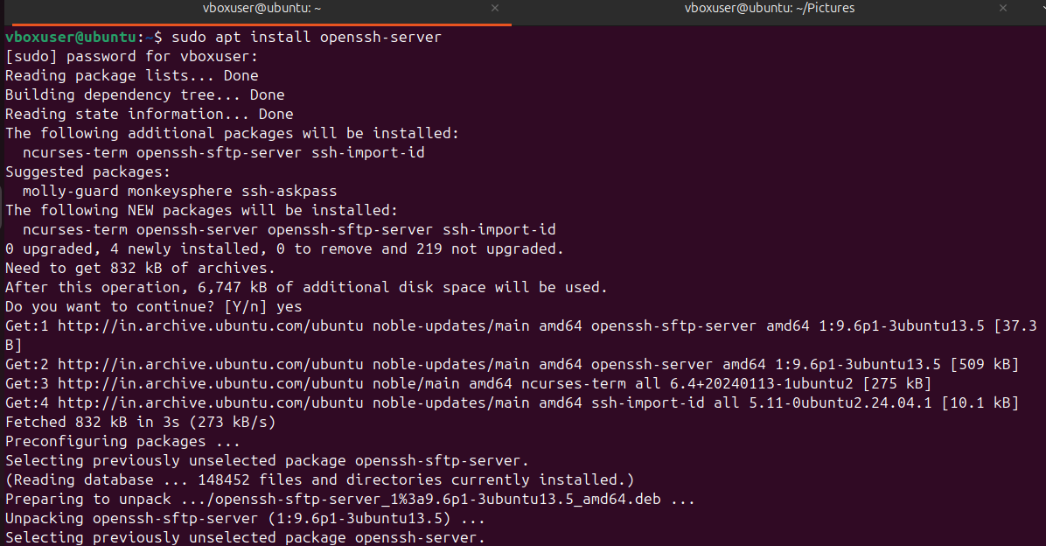

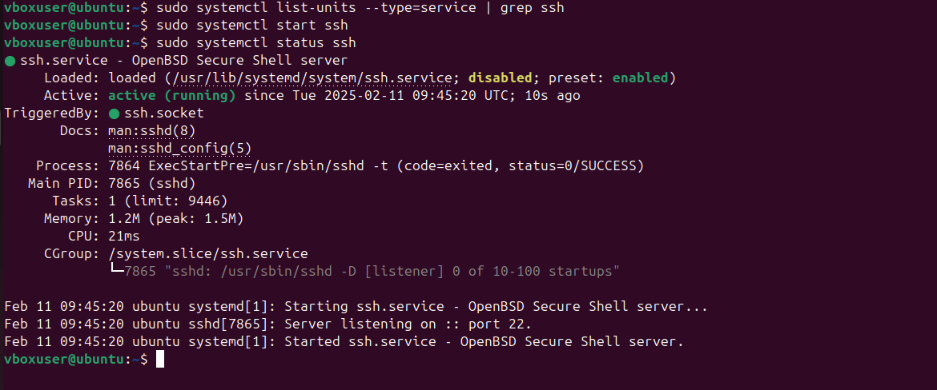

1. **Monitor log files using tail or grep:**



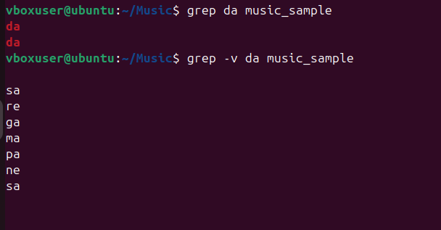

1. **Set up a webserver – nginx:**

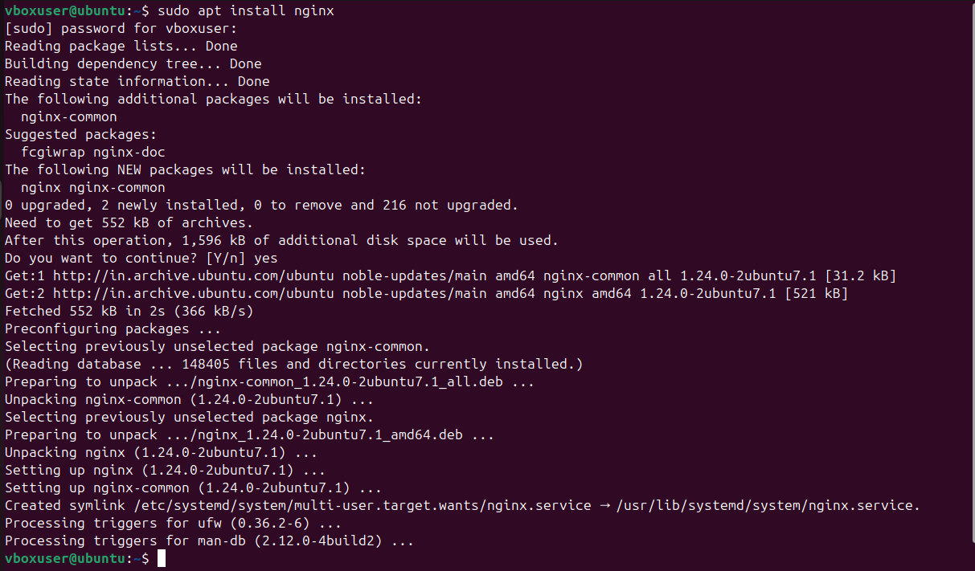

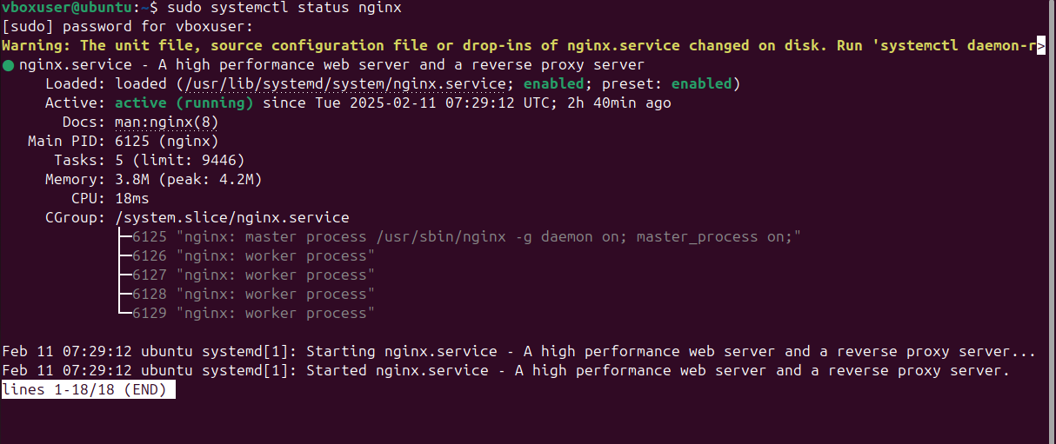

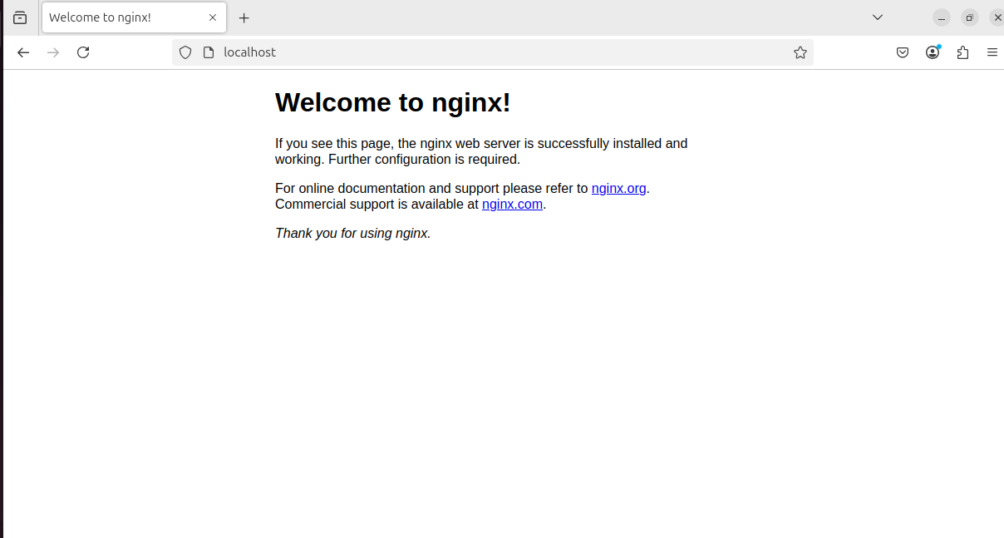

1. **Configure and secure a mysql database:**

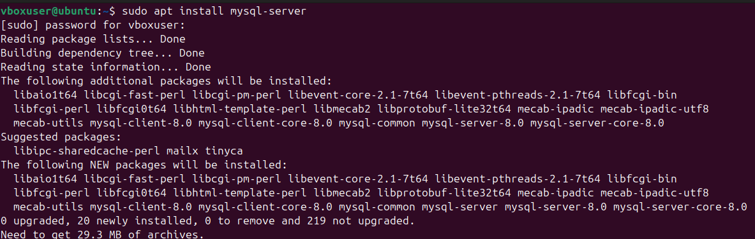

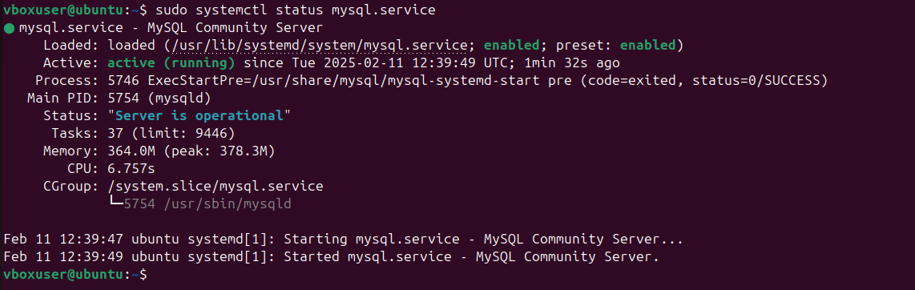

1. **Set up an Apllication server:**

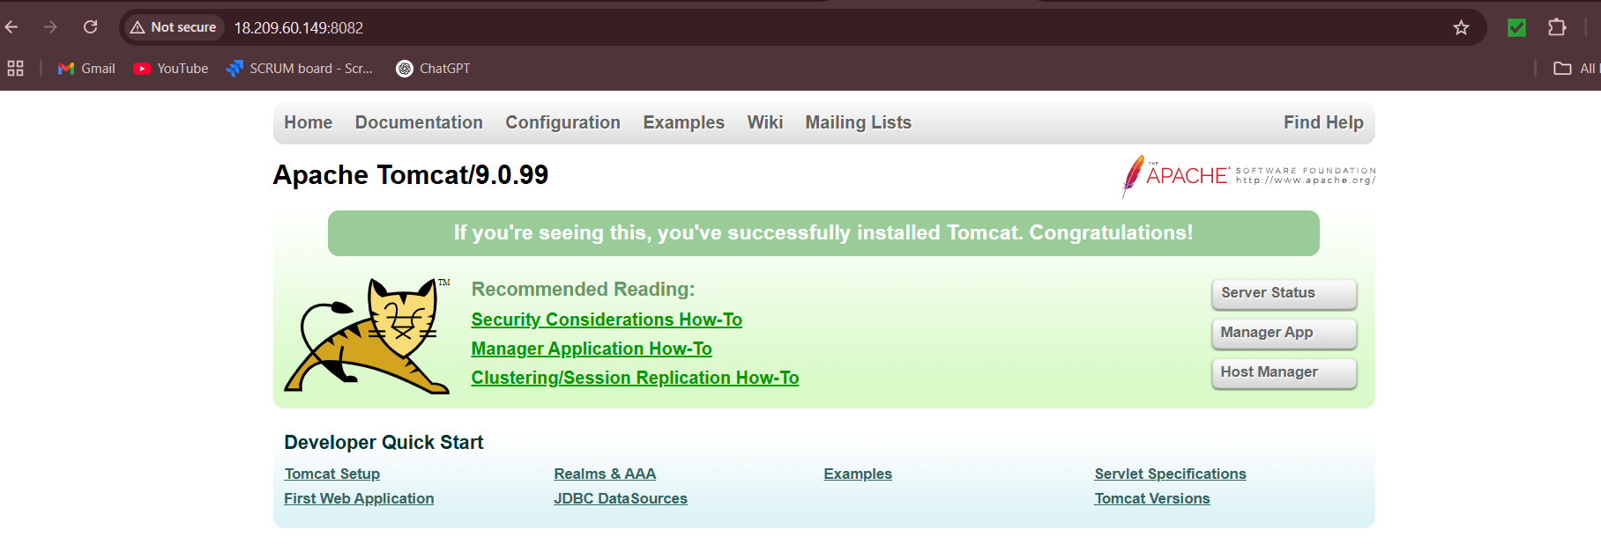

1. **Create a service file for tomcat:**

1. **Print specific coloumns of a delimited file:**

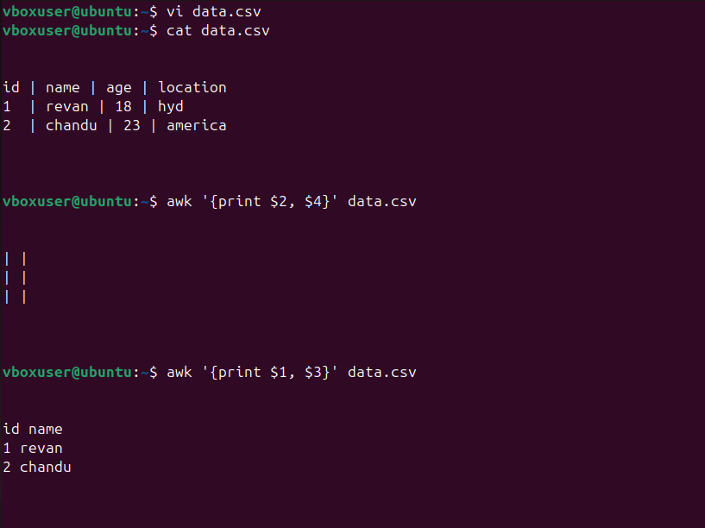

1. **Filter and print lines based on specific pattern or condition:**

**Condition where age is greater than 25 in coloumn 3**

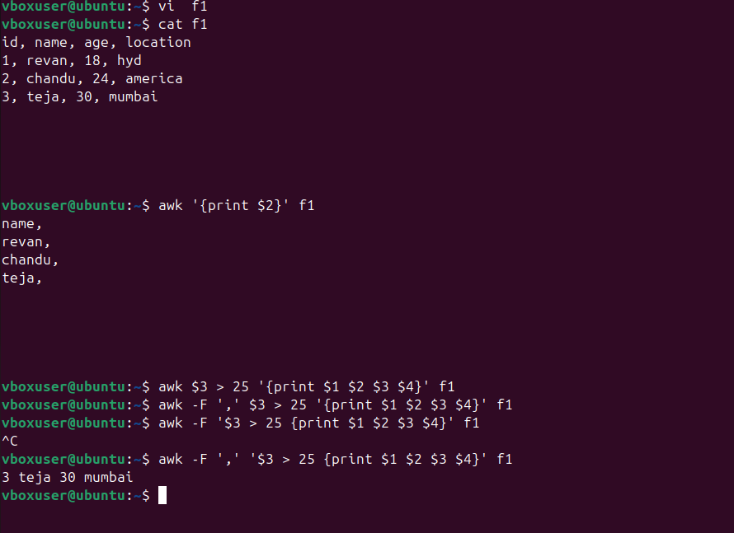

1. **Calculate and print avg, sum and other statistics of a coloumn:**

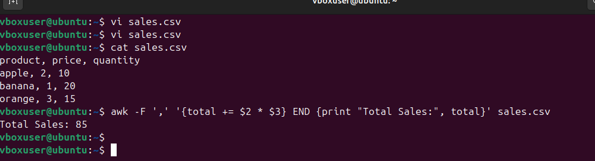

1. **perform string manipulation such as extracting substrings or changing case:**

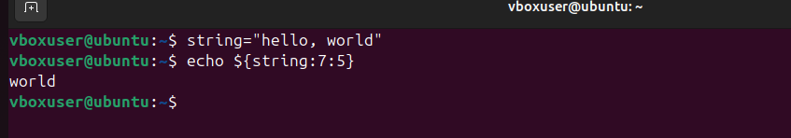

1. **Count the occurrences of a specific pattern in a file:**

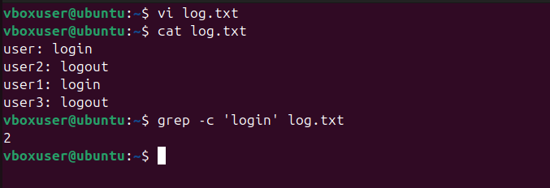

1. **Sort lines based on specific field or column:**

**To sort the file by third column based on ascending order**

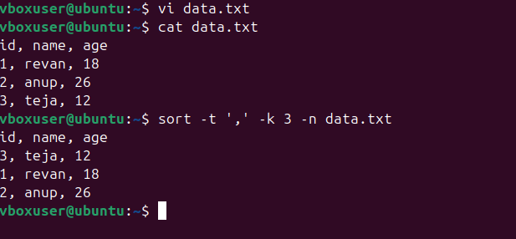

1. **Merge multiple files based on common fields or columns:**

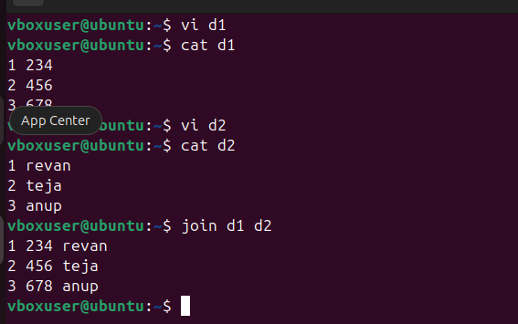

1. **Substitute text in a file using search and replace:**

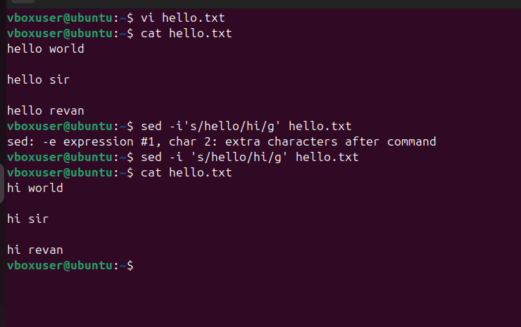

1. **Delete specific lines based on pattern or line number:**

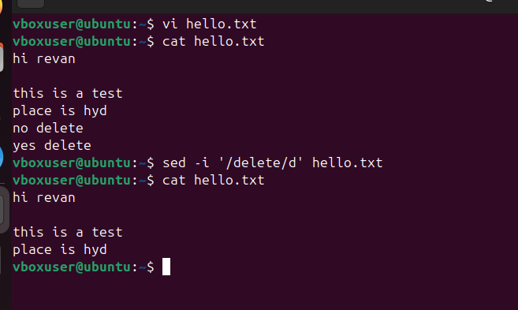

1. **Append or insert text before or after a specific pattern or line:**

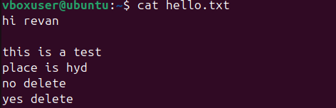



1. **Print only specific lines from a file:**

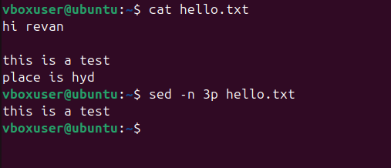

1. **5 use cases for awk and sed:**

**5 use cases of awk:**

1. **Print every line of the file:**

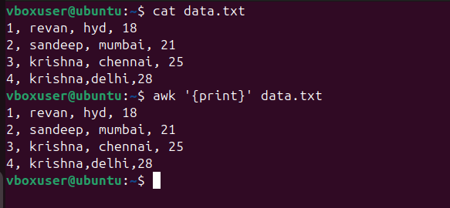

1. **Print specific columns:**



1. **To perform column statistics:** here, total sales is calculated by multiplying both 2nd and 3rd columns and their final sum calculated as ‘total sales’



1. **Print lines matching a pattern: pattern here is to print lines that contain the word ‘krishna’**

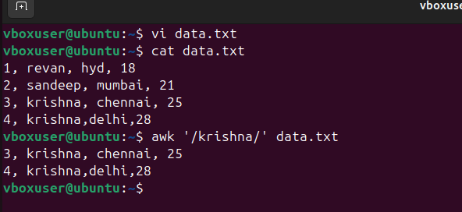

1. **To count the lines in a file:**

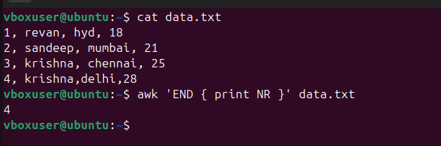

**5 use cases of sed:**

1. **To replace the first occurrence of a pattern in a line:** here, the word ‘unix’ is replaced by ‘linux’ in only its 1st occurrence in a line.

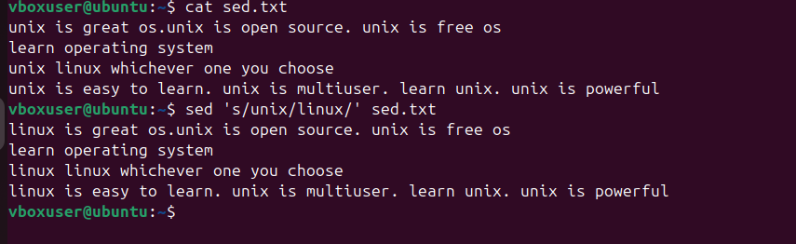

1. **To replace the nth occurrence of a pattern in a file:** here, the word ‘unix’ is replaced by ‘linux’ in its 2nd occurrence only

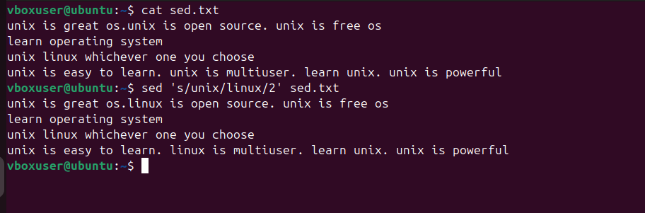

1. **To replace all the occurrences of the pattern in a file:**

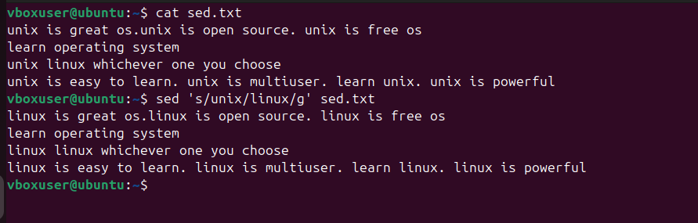

1. **To delete a particular line:**

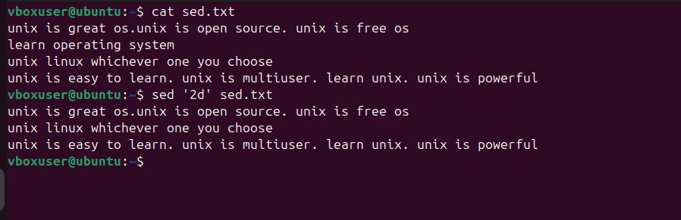

1. **To insert a blank line in a file:**

